Herts Welcomes Syrian Families
(HWSF)

Registered charity No 1172687

Support Syrian and other refugees
coming into Hertfordshire
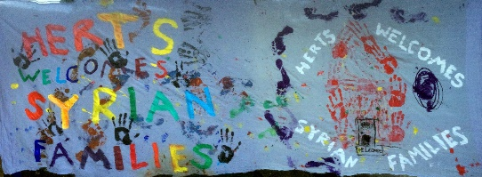

www.hwsf.org.uk
https://www.facebook.com/groups/HertsWelcomesSyrianFamilies

Chair: Irene Austin
chair@hwsf.org.uk
07463486048

Membership Secretary
membership@hwsf.org.uk

Donations:
treasurer@hwsf.org.uk

The objectives of HWSF are:

The relief of refugees and asylum seekers, in particular Syrian refugees by operating as a co-ordination and action network which will :

- Encourage local councils and the County Council to accept refugees under the Syrian Vulnerable Persons Scheme

- to work with local councils, the County Council and relevant organisations to ensure that refugees and asylum seekers have access to and are provided with appropriate services

- welcome refugees and asylum seekers and offer ongoing practical support

- to connect organisations and individuals who wish to support refugees and asylum seekers in order to enable their integration into the local community through the creation of a supportive and enabling environment

- to advance the education of the public in all aspects of the refugee situation, in particular, with reference to refugees of Syrian origin.

Membership form

Please complete and return this form to become a member of HWSF

Name:…………………………………

…………………………………………

Address: ………………….................

………………………………………….

Town/ City:
Postcode:

Tel:

Email:

Organisation (if applicable)

I agree to abide by the objectives of HWSF
Please tick

There is no membership fee

Please email the form to:

membership@hwsf.org.uk

Or send to:
HWSF c/o 52 Strathmore Avenue, Hitchin SG51ST

