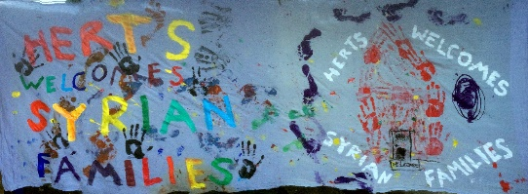
Agenda
Annual General Meeting Herts Welcomes Syrian Families(HWSF)
The Vineyard Church St Albans
7 Ashley Road, Brick Knoll Park,
Ashley Road Industrial Estate
St Albans AL15UG

Wednesday 28th February 2018
Refreshments and any new member registrations from 7.00
Main meeting 7.30 – 9.15
7.30 Welcome and introduction to the evening
7.40 - 8.10 Reports and confirmation of trustee posts
Chair’s Report Irene Austin & Treasurer’s report Mick Hayter
Trustees to continue:
Irene Austin
Samah Alrahabi
Gary Sutcliffe
Vicky Woodcraft
Catherine Henderson
Michael Hayter
Members to vote on this and on accounts
8.10 – 9.00
Syrian voices : A chance to hear the experiences of individuals now resettled in Hertfordshire.

9.00 – 9.15 Questions and closing discussion

